Encrypted
Securedline

S3CUR3DL1N3.com

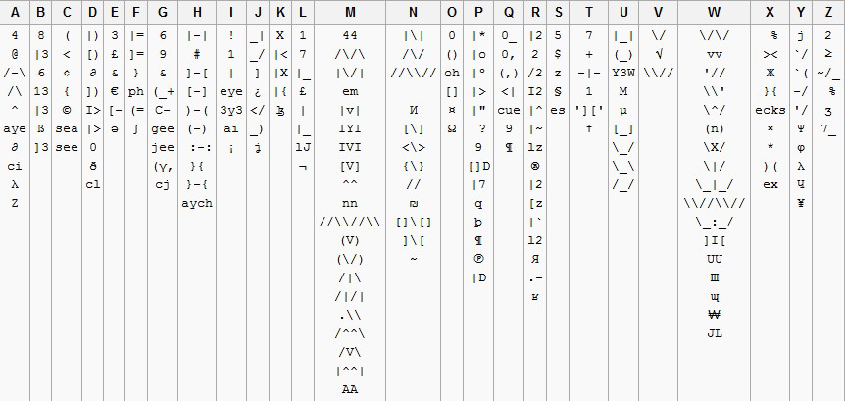

The book and Invites

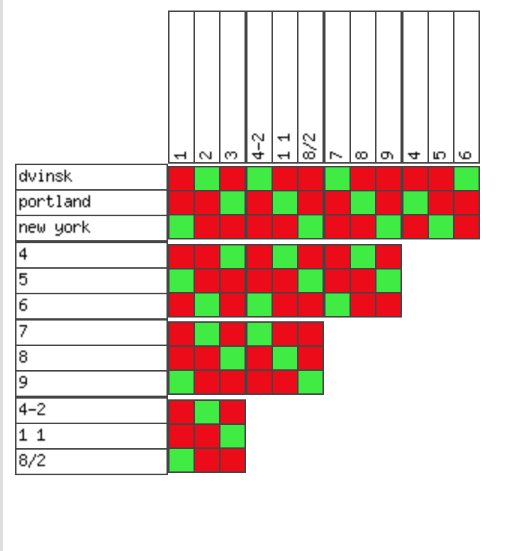
The case will open in dvinsk (2276)

I think this should be reworked to lead to a passphrase where we can redirect traffic

